Definitive instructions on cloning a repository and creating a key

1. Navigate to the root folder you want the repository in
2. Right-click anywhere and open Git Bash
3. Go into the repository and get the URL from the “Clone” button

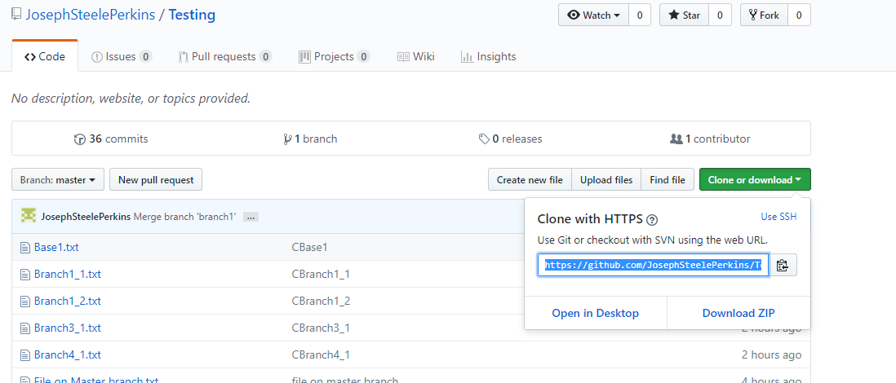

1. Cloning with HTTPS seems to work. SSH not sure. But HTTPS can be changed to SSH with this.

<https://help.github.com/articles/changing-a-remote-s-url/#switching-remote-urls-from-https-to-ssh>

1. Generate an SSH key as follows:

<https://help.github.com/articles/generating-a-new-ssh-key-and-adding-it-to-the-ssh-agent/>

1. Get your key from here…

C:\Users\Developer\.ssh\id_rsa

1. And add to GitHub

https://github.com/settings/keys